DevOps

Assignment 2017

Team Polo

Andrea Cole L00115856

Cathal Keany L00115066

Conor McGinty- L00117391

Liam Whorriskey- L00113360

Eimear Mc Cann- L00105764

Maria gibson- L00105748

B.Sc. in Computing

Enterprise Applications

Assignment 2017

Health insurance On-line system to enter

Customer’s details

By

Team Polo

Andrea Cole L00115856

Cathal Keany L00115066

Conor McGinty- L00117391

Liam Whorriskey- L00113360

Eimear Mc Cann- L00105764

Maria gibson- L00105748

Requested By

Lecture: Ruth Lennon

**Introduction**

**Project Overview**

This project has been developed by Group2 Team Polo for an Assignment in DevOps at Letterkenny Institute of Technology.

The system has been developed for a health insurance company, enabling customers to use an online system to enter their details. This system is designed to calculate the risk and produce the cost of insurance for the client. This is a secure system that’s takes in personal details, private health information and foreign travel.

Development has progressed over a number of weeks. This included individual work at home and group sessions in study rooms on a weekly basis. Meetings were scrum style Stand-up meetings to review progress. Working as a team the specification was defined. As the project progressed, Jira was used to track ongoing tasks. A GitHub repository was created to push documentation and upload code.

This document will provide an overview of the system planning, development and team integration.

**Scrums**

In the first Scrum Meeting, Use Case and State diagrams for health Insurance project were drawn.

All team members were present and contributed input to design outline and requirements.

Results are as follows:

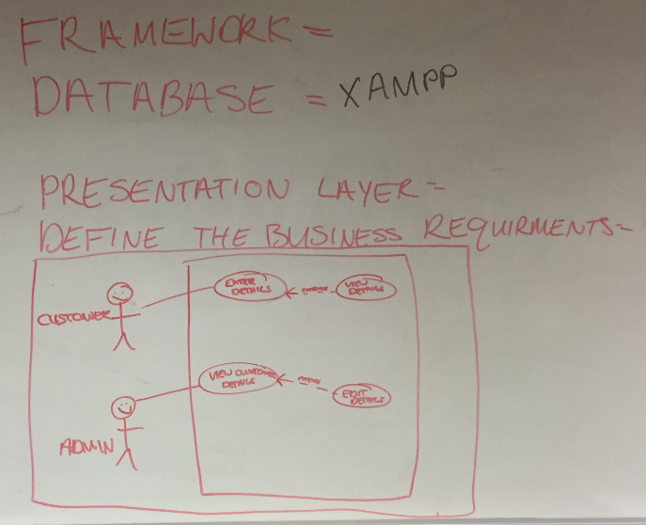

*Fig.1. Use Case Diagram Customer*

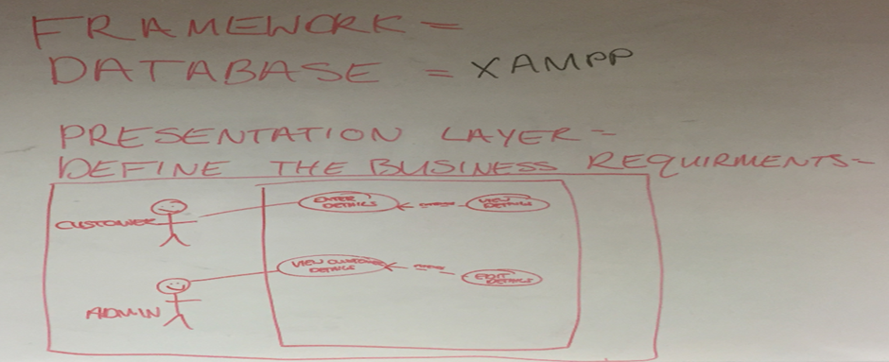  *Fig.2. Use Case Diagram Administrator*

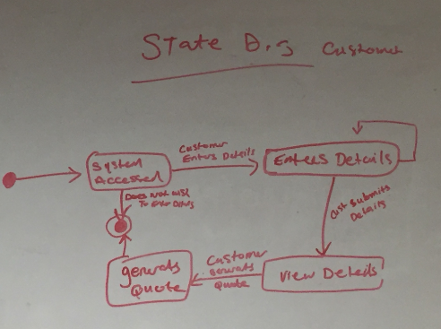

*Fig.3. State Diagram Customer*

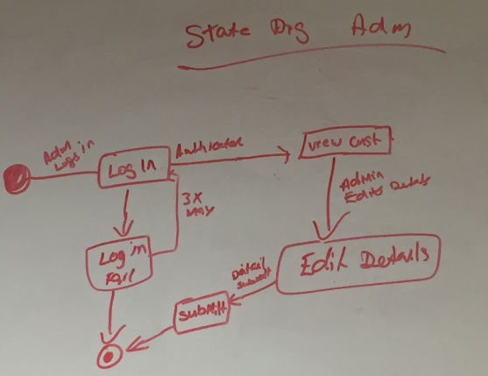*Fig.4. State Diagram Administrator*

**Summary**

Research was conducted into application design, testing, database development and web application. Results will highlight reason for chosen path in conducting this project. Java connection has now been requested by the Customer.

**Technical description of the project**

The web application will be hosted on a cloud server link192.com. The web application consists of a MySQL database that was created on AWS as a RDS instance, this was moved to PHP MyAdmin.

The database is connected using PHP to the website. The database contains two tables customer and customer quote. The parameters in the database define the loadings for the customers health insurance quote.

* ERD/Class Diagram
* Tables- Please see appendix

**Methodology (SDLC)**

The team decided to implement an Agile approach to project. This was chosen to allow team members to work to their strengths and independently. In an Agile team, all members must contribute equally during sprints and no team lead is assigned. When defining requirements for the system, various team members nominated themselves for preferred primary pieces of work. The project was broken up into the front-end requirements, middle ware requirements and backend.

**Development Technologies Used:**

Version Control - Github

The team set up a GitHub repository to use as a platform to share code and documentation for the project. However due to team members being inexperienced with this type of tool, it was used incorrectly. Some team members uploaded documentation to the repository which is illustrated in images in the appendix of this document. The evidence contained within the images in the appendix does not illustrate equal contribution of all team members. This illustration is not an accurate representation. All team members contributed equally. This confusion was a result of not using the repository from the beginning. This meant the teams approach to version control wasn’t competent.

Code Coverage

Team used Jacoco for code coverage as requested by customer.

Agile Scrums

The team communicated efficiently with the use of email and organised multiple weekly meetings to have scrums outside of scheduled class times. All team members attended the meetings and issues were discussed. Each meeting included team members demonstrating the work completed since previous meeting on an interactive screen. The short presentation provided an overview to all team members on the progress and build process of the project. After each meeting, team members had a clear vision of their next task(s) to be completed.

JIRA

JIRA is a progress tracking tool that was used by the team to track the progress of sprints. Each Sprint had a number of tasks and some tasks were drawn up and placed in the backlog. Jira was an efficient tool as it allowed team members to work independently outside of meetings and track each other’s progress. This tool provided an insight for team members on how Agile teams operate in Industry.

Junit Testing

Junit testing was used to test the code as illustrated in the images below.

Javadoc

Javadoc documentation generator was used whilst attempting to use JApplet.

**Application Considerations:**

**Database Design**

Reasons for using an SQL database for application

1. **High Speed**.

SQL queries can be used to search and fetch high volumes of data from database in a quick and efficient manner.

1. **Easy to Manage**

Using standard SQL means it is easy to manage the database without the need for a lot of code.

1. **Supports OOP**

SQL can support and communicate with object orientated programming e.g. java and JavaScript which makes it flexible when using a database for applications.

1. **Compatibility**

SQL Database can be used with Bootstrap which is the open source front end framework selected for the online application.

An RDS database has been created on AWS by Eimear on her aws account.

Hosting it on the cloud made it easier for two team members (Andrea and Eimear) to work on the database.

Access connection to the database on SQL workbench paste the following - *devops.cyivwen45nzy.us-east-2.rds.amazonaws.com*

Into the host section when setting up a new connection.

Use port 3306.

The password is grouppolo

Security group has been configured so anyone can access the database which is convenient for the purpose of this project

**Polo Insurance Database Instructions**

An SQL database was created for Polo Insurance using Amazon RDS services. It can be accessed by everyone after security groups have been configured to allow any IP to access the database.

Two tables were created as discussed, Customer table, which will include Name, address, phone etc, and a Quote table. The quote table will include if the customer is a smoker or travels outside Europe or US and so on. These tables will be updated as development progresses. The Log in details are noted below to access to the database.

Database Log in Details

**UserName:** Devops

**Password:** grouppolo

1. Download MySQL work bench (.NET and Visual c++ 2015 will have to be downloaded as prerequisites).
2. + to add a new hostname and enter the hostname stated below.
3. UserName and Password will have to be entered that is stated above.

**ENDPOINT:** devops.cyivwen45nzy.us-east-2.rds.amazonaws.com

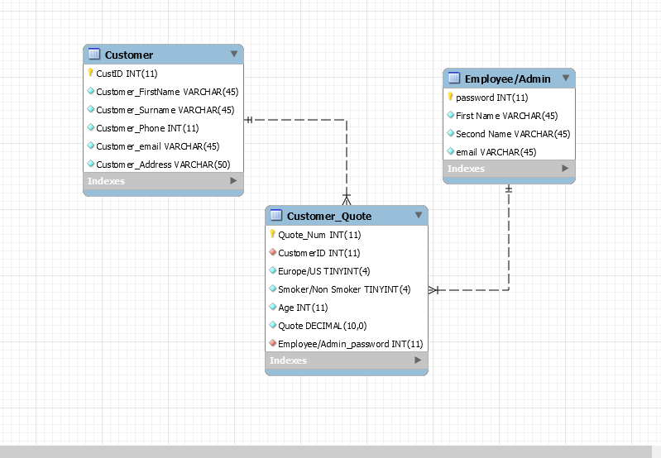

*Fig.5. ERD Diagram- Revers engineered in database*

By Nature of the project, there were continuous changes in the Agile environment. The database was then moved to another cloud hosting platform PHP MyAdmin, to allow for easier collaboration with PHP code and the website. This was an unexpected change that the team didn’t anticipate. This change was a team decision discussed at a scrum build meeting. This change also suited the team members skill sets better as not all team members were familiar with AWS tools.

**Web Design:** Liam Whorriskey and Maria Gibson. Maria had no prior experience on Web Development Liam agreed to mentor Maria in web design through a series of meetings to discuss design and development.

Discussion on Layout of web design page:

|  |
| --- |
| Navigation  Header  Side Bar  Content  Quote  Footer |

*Fig.6. Web Page Design*

Web Page Address on link192.com /http://link192.com/agents.php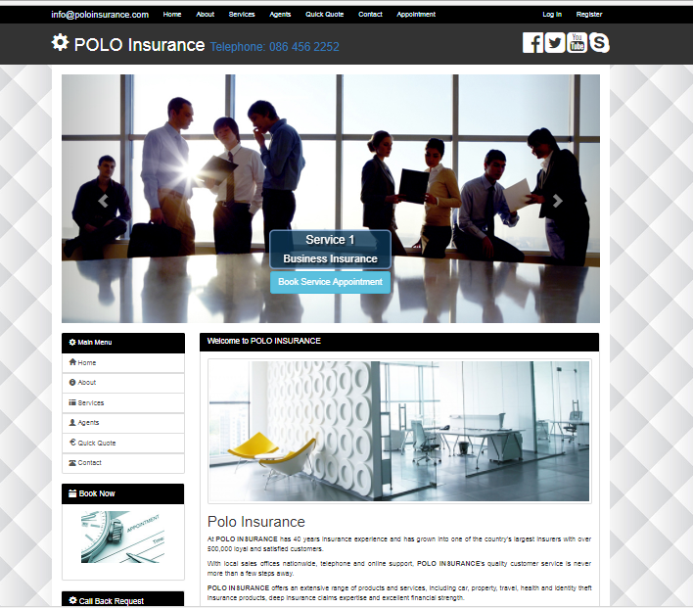

*Fig.7. Home Web Page*

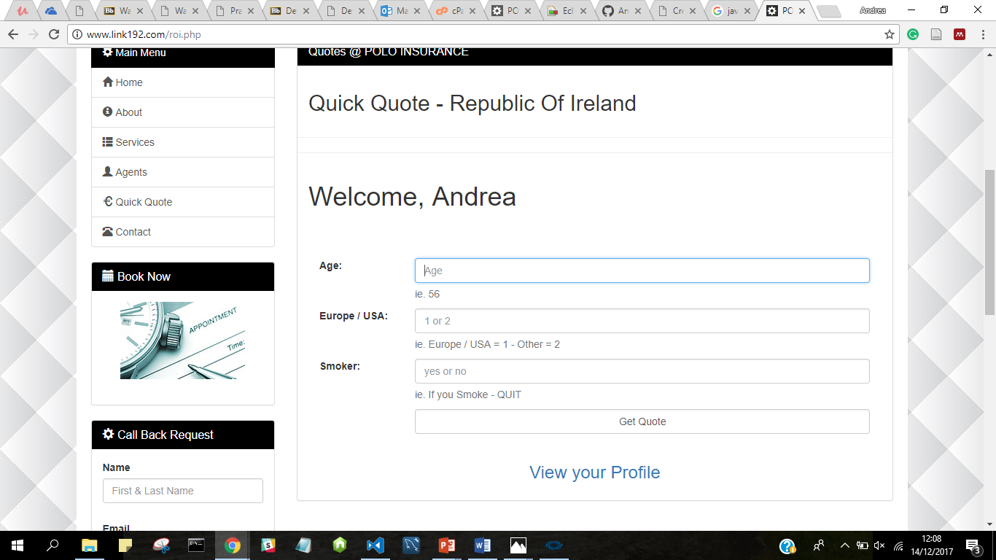

*Fig.8. Quote Webpage*

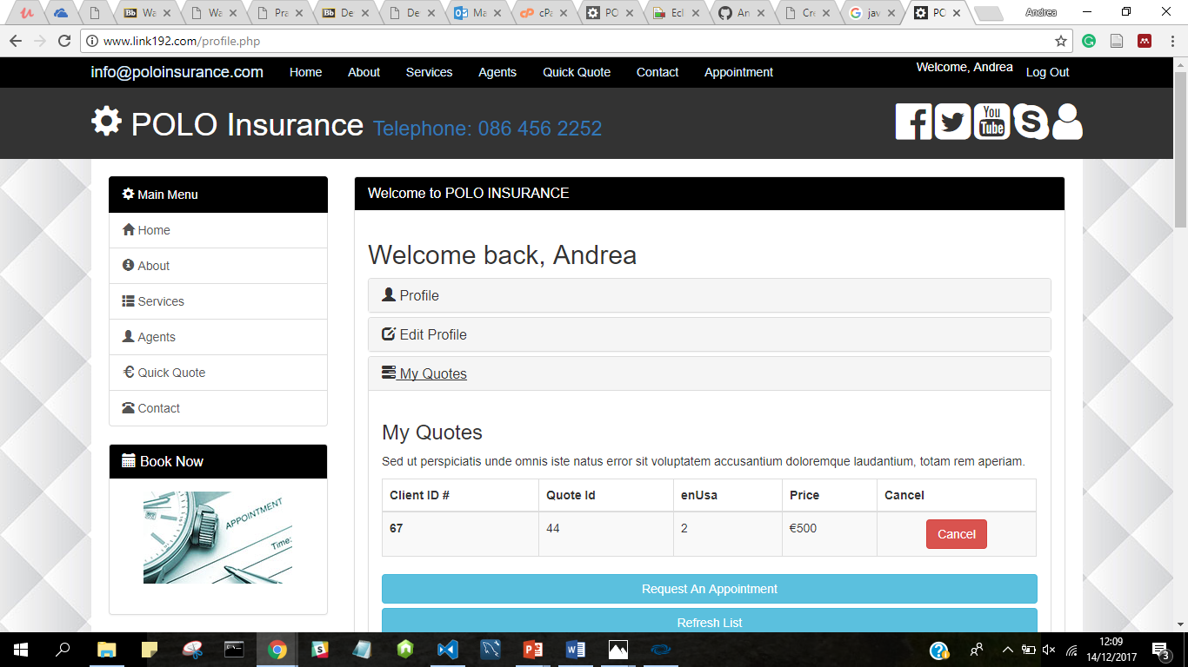

*Fig.9 Profile with quote result.*

New Proposed Contract

Customer met with Polo Insurance to review new requirements. The following agreement was reached and is highlight below in fig 9.New Contract Proposal

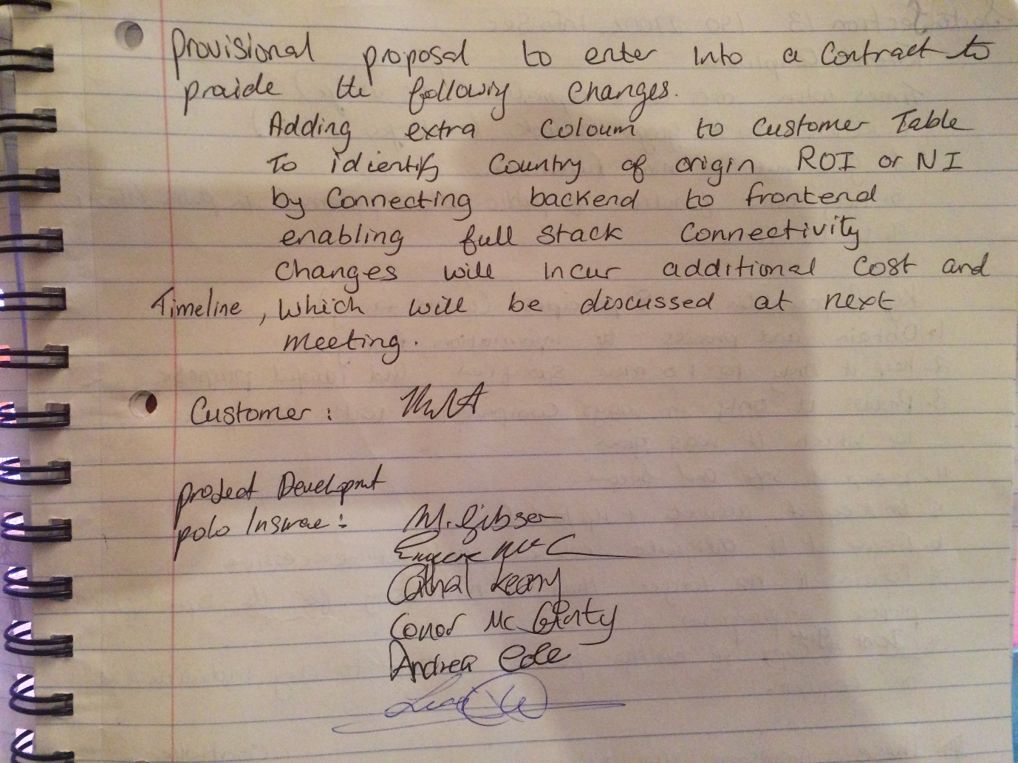

*Fig.10 New Contact*

**Appendices**

**Sample Tables in Database**

**Table 1.1**

**Customer Table**

|  |  |  |  |  |  |
| --- | --- | --- | --- | --- | --- |
| **ID** | **Name** | **Surname** | **Address** | **Email** | **Phone No.** |
| **Primary key** |  |  |  |  |  |
|  |  |  |  |  |  |

**Table 1.2**

**Quote Table**

|  |  |  |  |
| --- | --- | --- | --- |
| **Europe/US** | **Smoker/NonSmoker** | **Age** | **65+?** |
|  |  |  |  |